One way Booking
This document provides detailed steps for setting up and managing domestic, international, and cross-border routes. It covers adding operational cities, defining mandatory details like operational radius and distance rates, and configuring optional features such as surcharges, campaigns, amenities, and waiting time charges. Additionally, it explains how to associate suppliers or drivers with routes for efficient management.
Steps to Add a Domestic/International City
1. Navigate to Route Management
- Log in to the ops center.
- From the dashboard, locate and select Route Management from the navigation menu.
2. Go to Operational Cities
- Within the Route Management section, navigate to the Operational Cities tab.
3. Select the Domestic Tab
- In the Operational Cities tab, locate and select the Domestic tab.
4. Add Operational Cities
- Click on the Add Operational Cities button. A form will appear for entering details.
5. Fill in Operational Cities Details
- In the form, complete the following fields:
  - Route Type*: Select Domestic from the dropdown menu.
  - Zone*: Specify the zone for the route.
  - City*: Specify the city for the route.
- After filling in the necessary details, click the Submit button.
- The new domestic route will now be added to the list of operational cities.
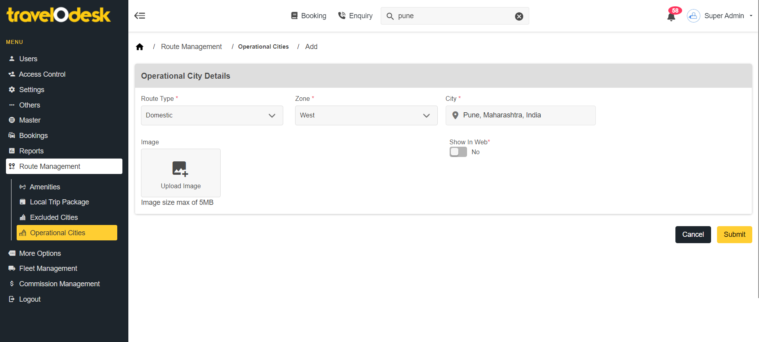

Steps to Add Details to a Domestic/International Route
1. Locate the Newly Added Operational City
- After adding a new operational city, navigate to the Operational Cities List.
- Locate the newly added operational city in the list.
- Click on the operational city to access the View section.
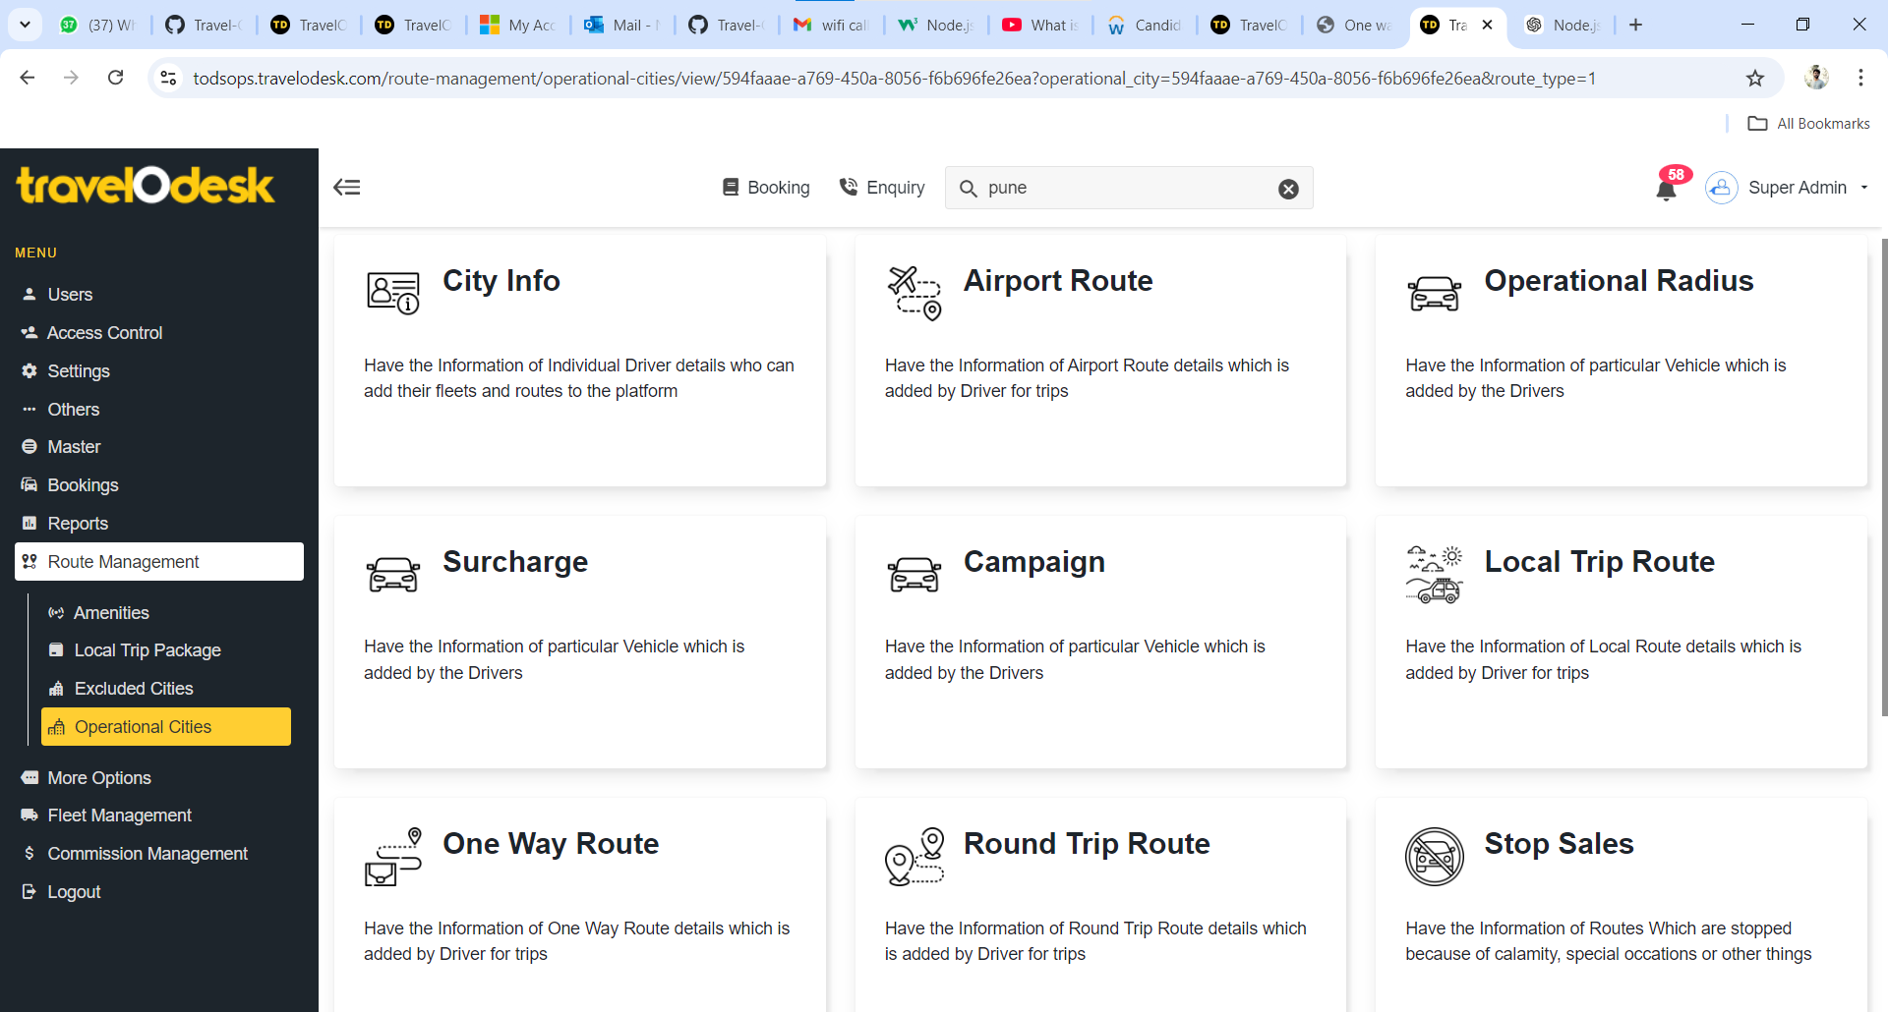

Steps to Add Mandatory Details
1. Add Operational Radius
- In the View section, select the Operational Radius tab.
- Complete the following fields:
  - Operational Radius in KMs*: Enter the maximum radius of operation.
  - Farthest Covering Distance in KMs*: Specify the maximum distance the route covers.
- Click Submit to save the details.
2. Add Distance Rate Details
- Return to the View section and select the Distance Rate tab.
- You will see a list of fleet options, such as:
  - Standard
  - People Carrier
  - Premium
- For each fleet type, fill in the following mandatory fields:
  - Initial Price*: Specify the base fare.
  - Included Distance*: Define the distance included in the base fare.
  - Price (Per KM)*: Enter the price for additional kilometer.
  - Next Distance*: Specify the next range of distances.
- Click Submit to save the details for each fleet type.

Steps to Add Optional Functionalities
1. Add Surcharge Details
- In the View section, navigate to the Surcharge tab.
- Enter any applicable surcharge amounts based on your operational needs (e.g., peak hour charges).
- Click Submit to save the details.
2. Add Campaign Details
- In the View section, navigate to the Campaign tab.
- Add promotional campaigns such as discounts, vouchers, or seasonal offers.
- Click Submit to save the campaign.
3. Add Stop Sales Details
- Navigate to the Stop Sales tab in the View section.
- Specify any dates or periods when the route will not operate.
- Click Submit to save the stop sales details.
4. Add Amenities
- In the View section, navigate to the Amenities tab.
- Select amenities from the free/paid available list, such as Wi-Fi, charging ports, refreshments, etc.
- Enable or disable amenities as required and click Submit to save the details.
5. Add Waiting Time Charges
- In the View section, navigate to the Waiting Time tab.
- Specify the following details:
  - Default Inclusion Waiting Minutes*: Define how many minutes of waiting time are included in the fare.
  - Additional Waiting Cost per 30 Minutes*: Specify the cost for extended waiting time beyond the included duration.
- Click Submit to save the waiting time charges.

Steps to Add Suppliers or Individual Drivers to an Operational City
1. Navigate to Users
- Log in to the ops center.
- From the dashboard, select Users from the navigation menu.
2. Select Suppliers/Individual Drivers
- In the Users section, locate the Suppliers/Individual Drivers tab.
- Select the supplier or individual driver for whom you want to add an operational city.
3. Access the View Tab
- Once the supplier or individual driver is selected, navigate to the View tab.
4. Add Operational City
- In the View tab, locate the Operational City section.
- Click on the Add Operational City button.
- Complete the following fields:
  - Route Type*: Select the type of route from the dropdown menu (e.g., Domestic).
  - City*: Specify the city to associate with the supplier or driver.
- Click Submit to save the details.
- You can verify the updated details in the Operational City section under the View tab.
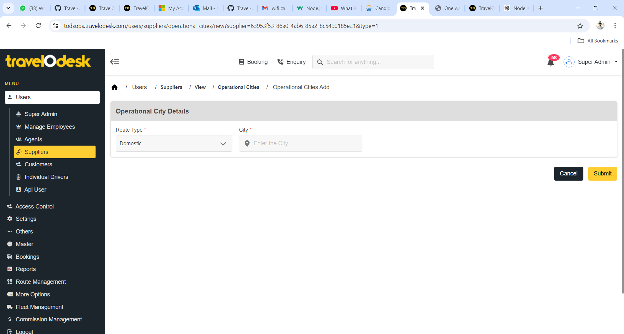

Steps to Add a Cross-Border Route
1. Navigate to Route Management
- Log in to the ops center.
- From the dashboard, locate and select Route Management from the navigation menu.
2. Select the Cross Border Tab
- Within the Route Management section, locate the Cross Border tab and select it.
3. Add Operational Cities
- Click on the Add Operational Cities button. A form will appear for entering details of the operational cities.
4. Fill in Operational Cities Details
Complete the following fields in the form:
- Route Type*:
  - Select Crossborder from the dropdown menu.
- Cross Border Name*:
  - Enter the name of the cross-border route.
- From Country, Zone, and City:
  - Specify the origin country, zone, and city.
- To Country, Zone, and City:
  - Specify the destination country, zone, and city.
5. Submit the Details
- Once all details have been filled in, click the Submit button.
6. Confirmation
- The new cross-border route will be added to the Crossborders List.
- Verify that the newly added route appears in the list.

Steps to Add Mandatory Details
1. Select the New Cross-Border Route
- Locate the newly added cross-border route in the Crossborders List.
- Click on the route to access the View section.
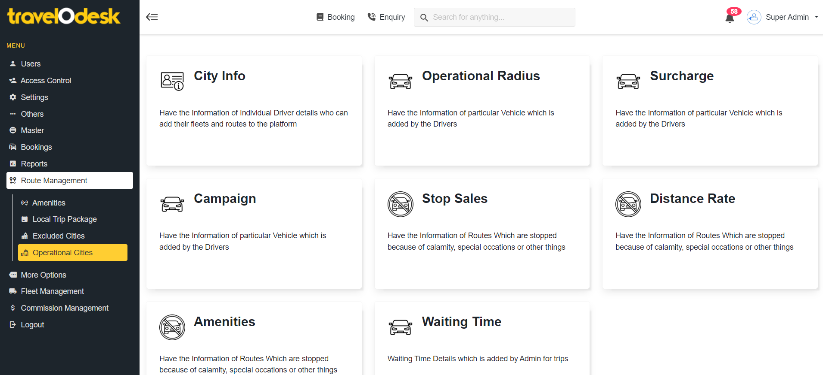
2. Add Operational Radius
- In the View section, select the Operational Radius tab.
- Enter the Operational Radius in KMs* and click Submit to save the details.
3. Add Distance Rate Details
- Return to the View section and select the Distance Rate tab.
- You will see a list of fleet options, such as:
  - Standard
  - People Carrier
  - Premium
4. Fill in Distance Rate Fields
For each fleet type, fill in the following mandatory fields:
- Initial Price*: Specify the base fare.
- Included Distance*: Define the distance included in the base fare.
- Price (Per KM)*: Enter the price for each additional kilometer.
- Next Distance*: Specify the next range of distances.
5. Submit the Distance Rate Details
- After completing all fields for a fleet, click Submit to save the details.
- Repeat the process for all fleet types listed.

Steps to Add Optional Functionalities
1. Add Surcharge Details
- In the View section, navigate to the Surcharge tab.
- Enter any applicable surcharge amounts based on your operational needs (e.g., peak hour charges).
- Click Submit to save the details.
2. Add Campaign Details
- In the View section, navigate to the Campaign tab.
- Add promotional campaigns such as discounts, vouchers, or seasonal offers.

3. Add Amenities
- In the View section, navigate to the Amenities tab.
- Select amenities from free and paid amenities available for this route, such as Wi-Fi, charging ports, refreshments, etc.
- Enable or disable amenities as needed and click Submit.
4. Add Waiting Time Charges
- In the View section, navigate to the Waiting Time tab.
- Specify the following details:
  - Default inclusion waiting minutes*
  - Waiting hours beyond ( cost for every 30min) *
- Click Submit to save the details.

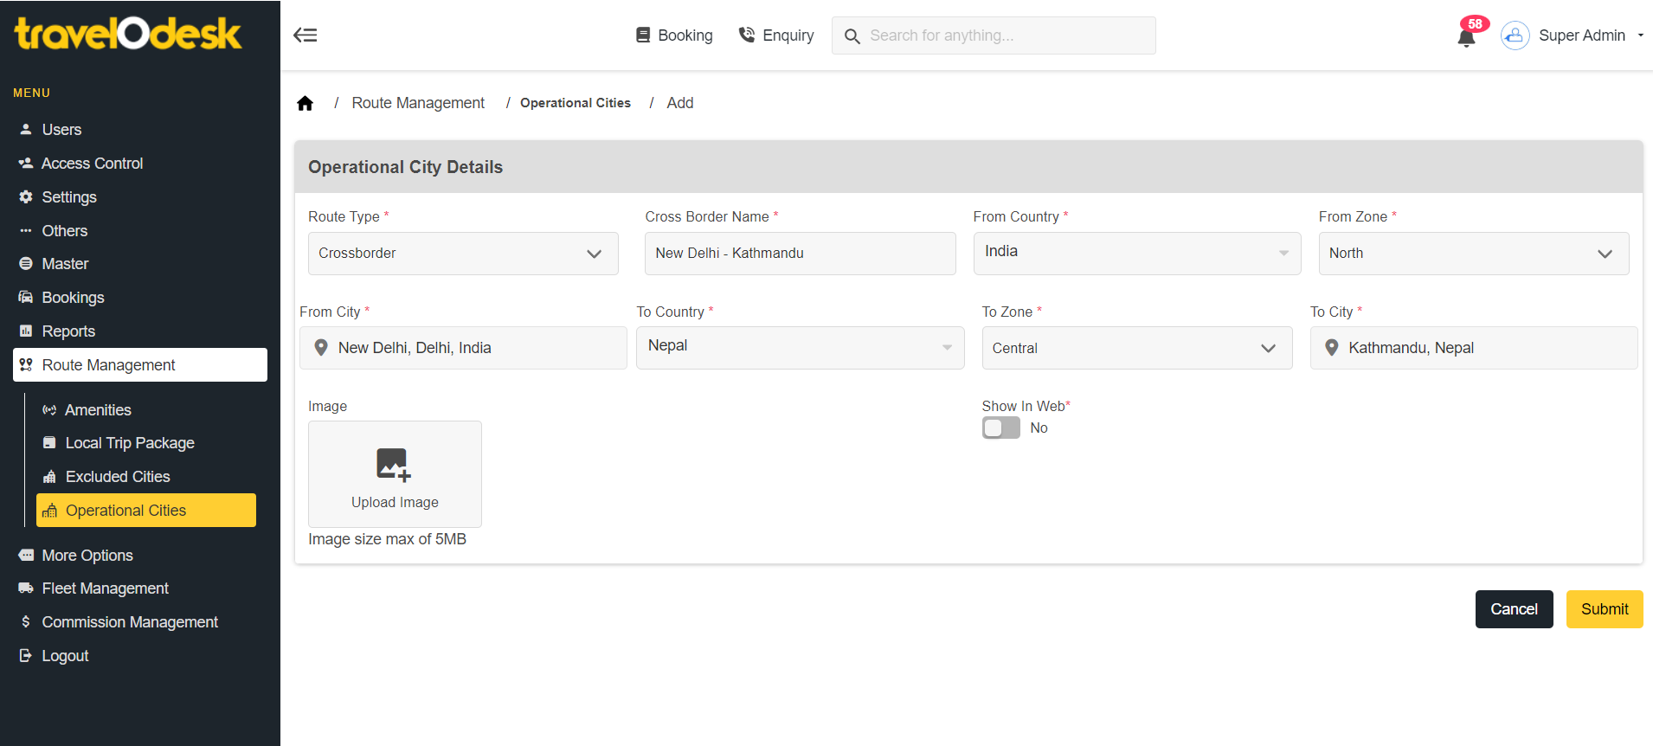

Steps to Add Suppliers or Individual Drivers to an Operational City
1. Navigate to Users
- Log in to the ops center.
- From the dashboard, select Users from the navigation menu.
2. Select Suppliers/Individual Drivers
- In the Users section, locate the Suppliers/Individual Drivers tab.
- Select the supplier or individual driver for whom you want to add an operational city.
3. Access the View Tab
- Once the supplier or individual driver is selected, navigate to the View tab.
4. Add Operational City
- In the View tab, locate the Operational City section.
- Click on the Add Operational City button.
- Complete the following fields:
  - Route Type* : Crossborder , From Country *, From City *
  - To Country *, To City *
- Click Submit to save the details.
- You can verify the updated details in the Operational City section under the View tab.

